- Week of : August 24, 2020 | Grade Level: Kindergarten
PYP Unit and Central Idea: Who We Are- Roles and responsibilities help us make connections.
Prioritized Standards Addressed This Week:
Math MGSEK.G.1 Describe objects in the environment using names of shapes, and describe the relative positions of these objects using terms such as above, below, beside, in front of, behind, and next to. MGSEK.G. 4 Analyze and compare two- and three-dimensional shapes, in different sizes and orientations, using informal language to describe their similarities, differences, parts (e.g., number of sides and vertices/“corners”) and other attributes (e.g., having sides of equal length).
Reading/ ELA ELAGSEKRL10: ELAGSEKRF3: Know and apply grade-level phonics and word analysis skills in decoding words. ELAGSEKRL1: With prompting and support, ask and answer questions about key details in a text

Science/ Social Studies SSKCG1 The student will demonstrate an understanding of good citizenship. SSKE1 Describe the work that people do such as: police officer, fire fighter, soldier, mail carrier, farmer, doctor, teacher, etc.

Asterisk & Highlighted items will be graded
Lessons Highlighted in blue will be Synchronous Lessons (Live in Teams) Synchronous – Live
Asynchronous – Not live

 | MONDAY | TUESDAY | WEDNESDAY | THURSDAY | FRIDAY

Student Login/  Morning Meeting (SEL)  8:15 a.m. | Focus Lessons:  Synchronous- Share Screen  Heards Ferry Live  SEL- Emotions  How Are You? Video and Discuss | Focus Lessons  Synchronous- Share Screen  Heards Ferry Live  **SEL-Emotions  How Are You? Activity | Focus Lessons  Synchronous- Share Screen  Heards Ferry Live  Morning Meeting | Focus Lessons  Synchronous- Share Screen  Heards Ferry Live  Morning Meeting | Focus Lessons  Synchronous- Share Screen  Heards Ferry Live  Morning Meeting  Announce student of the week for next week
Math  8:30 a.m. | No Synchronous Component - Please watch pre-recorded lesson and complete assignment listed below in “Student Independent Practice”  One on one assessment with students  8:30-9:00- Slot 1 | No Synchronous Component - Please watch pre-recorded lesson and complete assignment listed below in “Student Independent Practice”  One on one assessment with students  8:30-9:00- Slot 2 | No Synchronous Component - Please watch pre-recorded lesson and complete assignment listed below in “Student Independent Practice”  One on one assessment with students  8:30-9:00- Slot 3 | No Synchronous Component - Please watch pre-recorded lesson and complete assignment listed below in “Student Independent Practice”  One on one assessment with students  8:30-9:00- Slot 4 | No Synchronous Component - Please watch pre-recorded lesson and complete assignment listed below in “Student Independent Practice”  One on one assessment with students  8:30-9:00- Slot 5
 | Student Independent Practice  In Seesaw, find the activity below. Watch the instructional video and complete the assignment.  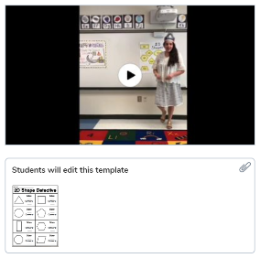 | Student Independent Practice  In Seesaw, find the activity below. Watch the instructional video and complete the assignment.  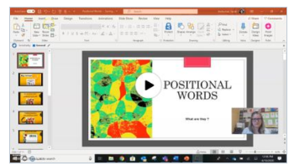 | Student Independent Practice  **In Seesaw, find the activity below. Watch the instructional video and complete the assignment.  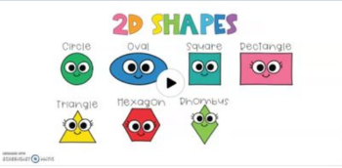 | Student Independent Practice  In Seesaw, find the activity below. Watch the instructional video and complete the assignment.  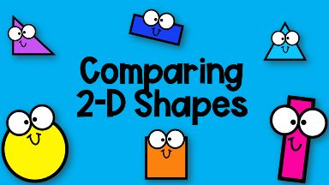 | Student Independent Practice  In Seesaw, find the activity below. Watch the instructional video and complete the assignment.  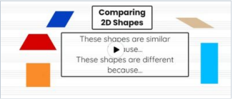
Specials  9:00am | You will find pre-recorded lessons and independent work from specials teachers on Seesaw in that specials folder. Please click on the student's name to see the drop-down menu and find their corresponding special. (See lesson overviews in the red table below.) | No Specials  Meet the counselor/diversity lesson | You will find pre-recorded lessons and independent work from specials teachers on Seesaw in that specials folder. Please click on the student's name to see the drop-down menu and find their corresponding special. (See lesson overviews in the red table below.) | You will find pre-recorded lessons and independent work from specials teachers on Seesaw in that specials folder. Please click on the student's name to see the drop-down menu and find their corresponding special. (See lesson overviews in the red table below.) | You will find pre-recorded lessons and independent work from specials teachers on Seesaw in that specials folder. Please click on the student's name to see the drop-down menu and find their corresponding special. (See lesson overviews in the red table below.)
Reading/ELA  10:00 a.m. | No Synchronous Component - Please watch pre-recorded phonics lesson and complete assignments listed below in “Student Independent Practice”  One on one assessment with students  10:00-10:30-Slot 6 | No Synchronous Component - Please watch pre-recorded read aloud and complete assignment listed below in “Student Independent Practice”  One on one assessment with students  10:00-10:30-Slot 7 | No Synchronous Component - Please watch pre-recorded phonics lesson and complete assignments listed below in “Student Independent Practice”  One on one assessment with students  10:00-10:30-Slot 8 | No Synchronous Component - Please watch pre-recorded read aloud and complete assignment listed below in “Student Independent Practice”  One on one assessment with students  10:00-10:30-Slot 9 | No Synchronous Component - Please watch pre-recorded phonics lesson and complete assignments listed below in “Student Independent Practice”  One on one assessment with students  10:00-10:30-Slot 10
 | Student Independent Practice  Reading  All About Me Book in Resource Folder- “I like to play with” page.  Phonics  Letter C Video  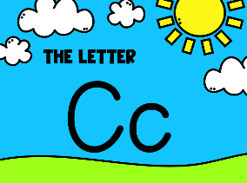  Alphabet Fashion Show  Newsletter for this is in your resource folder and on the Weebly under “Newsletters.” The vest is in the resource bag.  Post a picture of your student wearing their vest on Seesaw and then use the recording option to have students explain what is on their vest and why they chose it when complete. Alphabet Vest Due- August 28th | Student Independent Practice  Reading  Read Aloud Video- Knuffle Bunny  Log into Seesaw through Classlink and find the Knuffle Bunny read aloud to listen to the story!  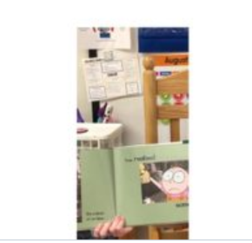  All About Me in Resource Folder - “I live with_____” page  Phonics  Login to iReady Reading through Classlink and work for 15 minutes on Reading.  Continue working on your Alphabet Vest if you need to.  If you finish your vest, you can work on Iready reading. | Student Independent Practice  Reading  All About Me in Resource Folder - “My favorite color is” page  Phonics  Letter O Video  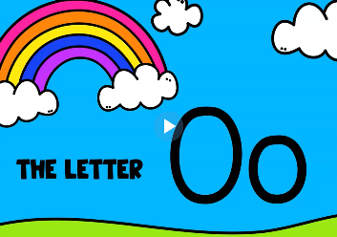  Continue working on your Alphabet Vest if you need to. | Student Independent Practice  Reading  Read Aloud Video- Silly Sally  Log into Seesaw Through Classlink and find the Silly Sally read aloud to listen to the story!  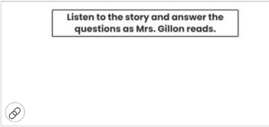  All About Me in Resource Folder - “I am in _____” page  Phonics  Login to iReady Reading through Classlink and work for 15 minutes on Reading.  Continue working on your Alphabet Vest if you need to. | Student Independent Practice  Reading  All About Me in Resource Folder - “I like to eat ____” page AND “I know how to _____”  Phonics  Letter O video  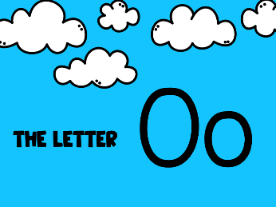  **Alphabet Fashion Show  Newsletter for this is in your resource folder and on the Weebly under “Newsletters.” The vest is in the resource bag.  Post a picture of your student wearing their vest on Seesaw and then use the recording option to have students explain what is on their vest and why they chose it when complete.  **Alphabet vest will be due this Friday, August 28th
Social Studies /Science  10:45 a.m. | Focused Lesson  Synchronous – Screen share read aloud - Epic Books: I am a Good Citizen  Discuss as a class. | Focused Lesson  Synchronous – Screen Share “Do Unto Otters “animated YouTube video:  Discuss as a class. | Focused Lesson  Synchronous -Good Citizen Or Not?  Teacher will read scenarios and students will draw a happy face if it is being a good citizen and a sad face if it is not being a good citizen. | Focused Lesson  Synchronous Problem and Solution  Teacher will read out different problem scenarios and students will come up with solutions. Discuss that coming up with solutions to our problems is a way of being a good citizen. | Focused Lesson  Synchronous- Teacher will explain the class wonder wall and that we inquire about the world around us as it relates to our current IB Unit.  Teacher will model her wonder.
 | Student Independent Practice  **Draw a picture of how you can be a good citizen. Post to Seesaw. | Student Independent Practice  Draw a picture of how you have been a good friend. Post to Seesaw. | Student Independent Practice  N/A | Student Independent Practice  N/A | Student Independent Practice  Students will write/draw what they wonder about community helpers, rules, or being a good citizen. Post to Seesaw.
Independent Work Time  12:00-12:45 | One on one assessment with students  12:00-12:30-Slot 11 | One on one assessment with students  12:00-12:30-Slot 12 | One on one assessment with students  12:00-12:30-Slot 13 | One on one assessment with students  12:00-12:30-Slot 14 | One on one assessment with students  12:00-12:30-Slot 15
Due Dates | All Independent practice activities will be due Friday September 11, 2020. | All Independent practice activities will be due Friday September 11, 2020. | All Independent practice activities will be due Friday September 11, 2020. | All Independent practice activities will be due Friday September 11, 2020. | All Independent practice activities will be due Friday September 11, 2020.  Alphabet Vest Due- August 28th

