Week of : August 31, 2020 | Grade Level: Kindergarten
PYP Unit and Central Idea: Who We Are- Roles and responsibilities help us make connections.
Prioritized Standards Addressed This Week:
Math MGSEK.G.1 Describe objects in the environment using names of shapes, and describe the relative positions of these objects using terms such as above, below, beside, in front of, behind, and next to. MGSEK.G. 4 Analyze and compare two- and three-dimensional shapes, in different sizes and orientations, using informal language to describe their similarities, differences, parts (e.g., number of sides and vertices/“corners”) and other attributes (e.g., having sides of equal length). MGSEK.MD.3 Classify objects into given categories; count the numbers of objects in each category and sort the categories by count. MGSE1.G.1 Distinguish between defining attributes (e.g., triangles are closed and three-sided) versus non-defining attributes (e.g., color, orientation, overall size); build and draw shapes to possess defining attributes.
Reading/ ELA ELAGSEKRL10: ELAGSEKRF3: Know and apply grade-level phonics and word analysis skills in decoding words. ELAGSEKRL1: With prompting and support, ask and answer questions about key details in a text

Science/ Social Studies SSKCG1 The student will demonstrate an understanding of good citizenship. SSKE1 Describe the work that people do such as: police officer, fire fighter, soldier, mail carrier, farmer, doctor, teacher, etc.

Asterisk & Highlighted items will be graded
Lessons Highlighted in blue will be Synchronous Lessons (Live in Teams)
Synchronous – Live Asynchronous – Not live

Weekly sight words: Weekly word family:
The -at (cat, sat, bat, rat, hat, mat, etc.)
I
to

 | MONDAY | TUESDAY | WEDNESDAY | THURSDAY | FRIDAY

Student Login/  Morning Meeting (SEL)/  Math  8:15 a.m. | Focus Lessons:  Synchronous- Share Screen  Heards Ferry Live  SEL- What Can You Do?  Video and Discuss | Focus Lessons  Synchronous- Share Screen  Heards Ferry Live  SEL- What Can You Do?  Activity | Focus Lessons  Synchronous- Share Screen  Heards Ferry Live  Morning Meeting | Focus Lessons  Synchronous- Share Screen  Heards Ferry Live  Morning Meeting | Focus Lessons  Synchronous- Share Screen  Heards Ferry Live  Morning Meeting  Announce student of the week for next week
Math  8:30 a.m. | Synchronous - Teacher will meet with Monday math small group.  -Calendar Math  -Defining vs. non defining attributes  - Anchor chart  - PPT Guided practice  If you are not meeting in small group, please watch pre-recorded lesson and complete assignment listed below in “Student Independent Practice” | Synchronous - Teacher will meet with Tuesday math small group.  -Calendar Math  -Defining vs. non defining attributes  - Anchor chart  - PPT Guided practice  If you are not meeting in small group, please watch pre-recorded lesson and complete assignment listed below in “Student Independent Practice” | Synchronous - Teacher will meet with Wednesday math small group.  -Calendar Math  -Defining vs. non defining attributes  - Anchor chart  - PPT Guided practice  If you are not meeting in small group, please watch pre-recorded lesson and complete assignment listed below in “Student Independent Practice” | Synchronous - Teacher will meet with Thursday math small group.  -Calendar Math  -Defining vs. non defining attributes  - Anchor chart  - PPT Guided practice  If you are not meeting in small group, please watch pre-recorded lesson and complete assignment listed below in “Student Independent Practice” | Synchronous - Whole Class  -Calendar Math  -Directed shape drawing- defining and non defining attributes  Please have the 2d shape paper from resource folder, plain paper, pencil, and crayons ready for this activity.  Students will use their 2d shape paper in their resource folder to help them trace/ draw pictures of shapes that the teacher calls out. Shapes will be different sizes and different colors and students will determine which attributes are defining and non-defining.
 | Student Independent Practice  In Seesaw, find the activity below. Watch the instructional video and complete the assignment.  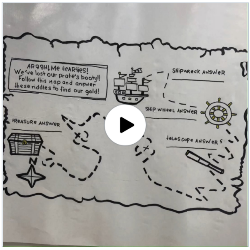 | Student Independent Practice  In Seesaw, find the activity below. Watch the instructional video and complete the assignment.  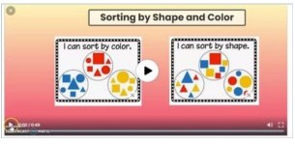 | Student Independent Practice  In Seesaw, find the activity below. Watch the instructional video and complete the assignment.  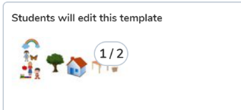 | Student Independent Practice  In Seesaw, find the activity below. Watch the instructional video and complete the assignment. | Student Independent Practice  Practice drawing different 2d shapes and making shapes out of materials around the house- playdough, straws, pipe cleaners, etc. Submit to seesaw.
Specials  9:00am | PE with Coach K  You will find pre-recorded lessons and independent work from specials teachers on Seesaw in that specials folder. Please click on the student's name to see the drop-down menu and find their corresponding special. | No Specials- Go Noodle, Iready, break, independent practice, etc.  You will find pre-recorded lessons and independent work from specials teachers on Seesaw in that specials folder. Please click on the student's name to see the drop-down menu and find their corresponding special. | PE with Coach K  You will find pre-recorded lessons and independent work from specials teachers on Seesaw in that specials folder. Please click on the student's name to see the drop-down menu and find their corresponding special. | Music with Mrs. LeSaicherre  You will find pre-recorded lessons and independent work from specials teachers on Seesaw in that specials folder. Please click on the student's name to see the drop-down menu and find their corresponding special. | Art with Mrs. Strom  You will find pre-recorded lessons and independent work from specials teachers on Seesaw in that specials folder. Please click on the student's name to see the drop-down menu and find their corresponding special.
Reading/ELA  10:00 a.m. | Synchronous - Teacher will meet with Monday reading small group.  -Mrs. Wishy Washy  - Patterns  - Talking like the character  - One to one correspondence  - Predictions  - Inferencing  - Eagle eye reading strategy  If you are not meeting in small group, please watch pre-recorded lesson and complete assignment listed below in “Student Independent Practice” | Synchronous - Teacher will meet with Tuesday reading small group.  -Mrs. Wishy Washy  - Patterns  - Talking like the character  - One to one correspondence  - Predictions  - Inferencing  - Eagle eye reading strategy  If you are not meeting in small group, please watch pre-recorded lesson and complete assignment listed below in “Student Independent Practice” | Synchronous - Teacher will meet with Wednesday reading small group.  -Mrs. Wishy Washy  - Patterns  - Talking like the character  - One to one correspondence  - Predictions  - Inferencing  - Eagle eye reading strategy  If you are not meeting in small group, please watch pre-recorded lesson and complete assignment listed below in “Student Independent Practice” | Synchronous - Teacher will meet with Thursday reading small group.  -Mrs. Wishy Washy  - Patterns  - Talking like the character  - One to one correspondence  - Predictions  - Inferencing  - Eagle eye reading strategy  If you are not meeting in small group, please watch pre-recorded lesson and complete assignment listed below in “Student Independent Practice” | Synchronous-Whole Class  Introduce blending board-  - Say the letter sounds  - Write the letter in the air (C,O,A,D)  - Blend sounds together  Read aloud- Elephant and Piggie: We Are In a Book!
 | Student Independent Practice  Reading  EPIC Books- Explore EPIC books and read/listen to a story of your choice.  Phonics  Find the Seesaw lesson on the letter A. After watching the video, sort the pictures by dragging them to the correct column: words that begin with A or words that do NOT begin with A. | Student Independent Practice  Reading  Please watch the “Goldilocks and the Three Bears” read aloud by Mrs. Gillon on Seesaw.  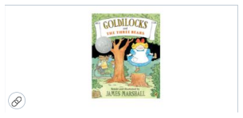  Phonics  Seesaw pre-recorded phonics lesson and activity.  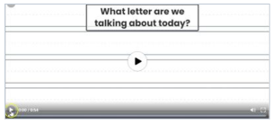 | Student Independent Practice  Reading  EPIC Books- Explore EPIC books and read/listen to a story of your choice. On Seesaw, tell the name of the story you read, what happened in the story, and if you liked the book or not.  Phonics  Seesaw pre-recorded phonics lesson and activity.  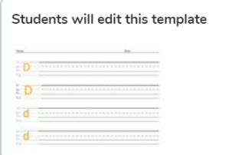 | Student Independent Practice  Reading  EPIC Books- Explore EPIC books and read/listen to a story of your choice.  Phonics  Seesaw pre-recorded phonics lesson and activity. | Student Independent Practice  Reading  Please watch the “ Dusty Locks and the Three Bears “read aloud by Ms. Frank on Seesaw.  Phonics  Seesaw pre-recorded phonics lesson and activity. 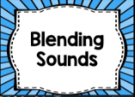
Social Studies /Science  10:45 a.m. | Focused Lesson  Police officer-  No synchronous component. Please watch the video on Seesaw and complete the assignment. | Focused Lesson  Park Ranger  No synchronous component. Please find the assigned book Park Rangers, on Epic! Books. Listen to the story and then complete the assignment on Seesaw. | Focused Lesson  Assistant Principal/Teacher  No synchronous component.  Please watch the video on Seesaw and complete the assignment. | Focused Lesson  No synchronous component. Please watch the video on Seesaw and complete the assignment. | Focused Lesson  Vet  No synchronous component. Please watch the video on Seesaw and complete the assignment.
 | Student Independent Practice  On Seesaw, listen to the story “Officer Buckle and Gloria” and complete the assignment. | Student Independent Practice  Park Ranger sentence completion on Seesaw.  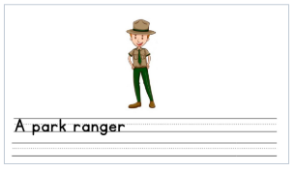 | Student Independent Practice  On Seesaw, listen to the story “My Teacher for President” and complete the assignment. | Student Independent Practice  On Seesaw, listen to the story "David goes to School” and complete the assignment. | Student Independent Practice  Find the video read aloud on Seesaw. After listening, use the voice recording tool to say ways that doctors and vets are similar and how they are different.
Independent Work time  12:00-12:45 | Finish any Independent practice activities  Iready reading | Finish any Independent practice activities  Iready math | Finish any Independent practice activities  Iready reading | Finish any Independent practice activities  Iready math | Finish any Independent practice activities  Iready reading
Due Dates | All Independent practice activities will be due Friday September 11th. | All Independent practice activities will be due Friday  September 11th. | All Independent practice activities will be due Friday  September 11th. | All Independent practice activities will be due Friday  September 11th. | All Independent practice activities will be due Friday  September 11th.

