Week of : September 14, 2020 | Grade Level: Kindergarten
PYP Unit and Central Idea: Who We Are- Roles and responsibilities help us make connections.
Prioritized Standards Addressed This Week:
Math MGSEK.G.1 Describe objects in the environment using names of shapes, and describe the relative positions of these objects using terms such as above, below, beside, in front of, behind, and next to. MGSEK.G. 4 Analyze and compare two- and three-dimensional shapes, in different sizes and orientations, using informal language to describe their similarities, differences, parts (e.g., number of sides and vertices/“corners”) and other attributes (e.g., having sides of equal length).
Reading/ ELA ELAGSEKRL10: ELAGSEKRF3: Know and apply grade-level phonics and word analysis skills in decoding words. ELAGSEKRL1: With prompting and support, ask and answer questions about key details in a text

Science/ Social Studies SSKCG1 The student will demonstrate an understanding of good citizenship. SSKE1 Describe the work that people do such as: police officer, fire fighter, soldier, mail carrier, farmer, doctor, teacher, etc.

Asterisk & Highlighted items will be graded
Lessons Highlighted in blue will be Synchronous Lessons (Live in Teams)
Synchronous – Live Asynchronous – Not live

Weekly sight words: Weekly word family:
go -ag (rag, sag, zag, bag, nag, lag, etc.)
me
like

 | MONDAY | TUESDAY | WEDNESDAY | THURSDAY | FRIDAY

Student Login/  Morning Meeting (SEL)  8:15 a.m. | Focus Lessons  Synchronous- Share Screen  Heards Ferry Live  SEL- How Can You Bounce Back?  Video and Discuss | Focus Lessons  Synchronous- Share Screen  Heards Ferry Live  SEL- How Can You Bounce Back? | Focus Lessons  Synchronous- Share Screen  Heards Ferry Live  Morning Meeting | Counselor Lesson-Listening  Focus Lessons  Synchronous- Share Screen  Heards Ferry Live  Morning Meeting | Focus Lessons  Synchronous- Share Screen  Heards Ferry Live  Morning Meeting  Announce student of the week for next week
Math  8:30 a.m. | Synchronous - Teacher will meet with Monday math small group.  3d shapes  If you are not meeting in small group, please watch pre-recorded lesson and complete assignment listed below in “Student Independent Practice” | Synchronous - Teacher will meet with Tuesday math small group.  3d shapes  If you are not meeting in small group, please watch pre-recorded lesson and complete assignment listed below in “Student Independent Practice” | Synchronous - Teacher will meet with Wednesday math small group.  3d shapes  If you are not meeting in small group, please watch pre-recorded lesson and complete assignment listed below in “Student Independent Practice” | Synchronous - Teacher will meet with Thursday math small group.  3d shapes  If you are not meeting in small group, please watch pre-recorded lesson and complete assignment listed below in “Student Independent Practice” | Synchronous -Whole group  2d/3d shape jeopardy  Students will complete independent practice activities when finished in whole group math.  Seesaw lesson and activity- making 3d shapes out of different materials
 | Student Independent Practice  In Seesaw, find the activity below. Watch the instructional video and complete the assignment.  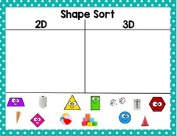 | Student Independent Practice  In Seesaw, find the activity below. Watch the instructional video and complete the assignment.  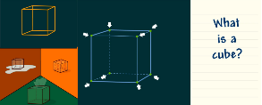 | Student Independent Practice  In Seesaw, find the activity below. Watch the instructional video and complete the assignment.  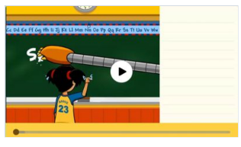 | Student Independent Practice  In Seesaw, find the activity below. Watch the instructional video and complete the assignment.  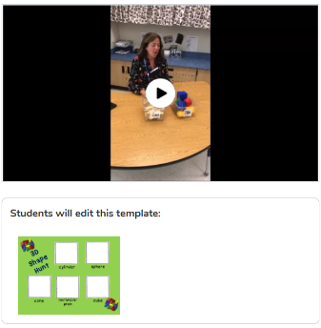 | Student Independent Practice  In Seesaw, find the activity below. Watch the instructional video and  complete the assignment.  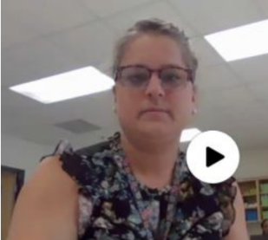
Specials  9:00am | PE with Coach K  Specials will now be conducted in Teams instead of Seesaw. When you join your specials team, find and click on the channel with our day and class name on it.  If you have any assignments to turn in, you will continue to submit them via Seesaw. | No specials day- Go Noodle, Iready reading and/or math, catch up on/begin independent practice, EPIC books, etc. | PE with Coach K  Specials will now be conducted in Teams instead of Seesaw. When you join your specials team, find and click on the channel with our day and class name on it.  If you have any assignments to turn in, you will continue to submit them via Seesaw. | Music with Mrs. LeSaicherre  Specials will now be conducted in Teams instead of Seesaw. When you join your specials team, find and click on the channel with our day and class name on it.  If you have any assignments to turn in, you will continue to submit them via Seesaw. | Art with Mrs. Strom  Specials will now be conducted in Teams instead of Seesaw. When you join your specials team, find and click on the channel with our day and class name on it.  If you have any assignments to turn in, you will continue to submit them via Seesaw.
Reading/ELA  10:00 a.m. | Synchronous - Teacher will meet with Monday reading small group.  -Guided reading  If you are not meeting in small group, please watch pre-recorded lesson and complete assignment listed below in “Student Independent Practice” | Synchronous - Teacher will meet with Tuesday reading small group.  -Guided reading  If you are not meeting in small group, please watch pre-recorded lesson and complete assignment listed below in “Student Independent Practice” | Synchronous - Teacher will meet with Wednesday reading small group.  -Guided Reading  If you are not meeting in small group, please watch pre-recorded lesson and complete assignment listed below in “Student Independent Practice” | Synchronous - Teacher will meet with Thursday reading small group  -Guided Reading  If you are not meeting in small group, please watch pre-recorded lesson and complete assignment listed below in “Student Independent Practice” | Synchronous -Whole group  -3 Billy Goats Gruff  Students will complete independent practice activities when finished in whole group reading.
 | Student Independent Practice  Reading  Watch the reading lesson on Seesaw called “Readers can read stories they have heard a zillion times.”  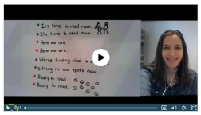  The assignment today is listening to “The Three Billy Goats Gruff” read aloud which can be found on Seesaw.  Phonics  Watch the video lesson on Seesaw. Practice writing uppercase and lowercase letter Ll. Then, circle the correct beginning sound for each picture. | Student Independent Practice  Reading  On Seesaw, watch the reading lesson on “Making the Words and the Pictures Match” and complete the assignment.  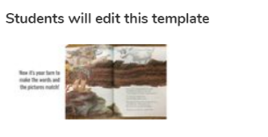  Phonics  Watch the video lesson on Seesaw. Then, draw a picture of something that begins with the letter L. Don’t forget to fill in the word to complete the sentence.. | Student Independent Practice  Writing  On seesaw, atch the video. Then, think about what you want to say about your topic and put it on your paper. Take a picture for Seesaw  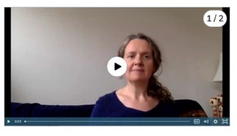  Phonics  Watch the video lesson on the letter H. Then, draw a line from each picture to its correct beginning sound. 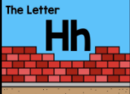 | Student Independent Practice  Writing  On Seesaw, watch the video. Then, write the next page in your book. Stretch out words to make sure that you write a letter for every sound that you hear!  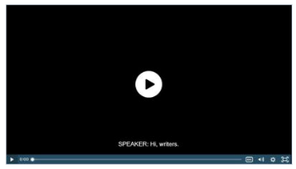  Phonics  Watch the video lesson on the Letter H. Then, find two items around the house that begin with the letter H and take a picture of them.  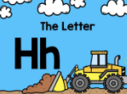 | Student Independent Practice  Phonics  Blending Board  Watch the instructional video and then complete the activity.
Social Studies /Science  10:45 a.m. | Focused Lesson  No synchronous component. Please watch the video on community helpers answering your questions from last week! | Focused Lesson  No synchronous component. Please watch the video on community helpers answering your questions from last week! | Focused Lesson  No synchronous component. Please watch the video on community helpers answering your questions from last week! | Focused Lesson  No synchronous component. Please watch the video on community helpers answering your questions from last week! | Focused Lesson  International Inquirer
 | Student Independent Practice  Record yourself telling something interesting you learned from the chef  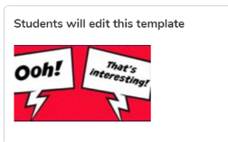 | Student Independent Practice  Record yourself telling something interesting you learned from the doctor  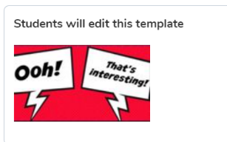 | Student Independent Practice  Record yourself telling something interesting you learned from the vet  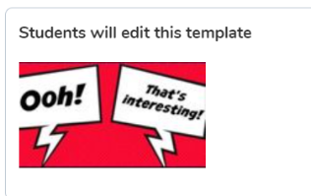 | Student Independent Practice  Record yourself telling something interesting you learned from the police  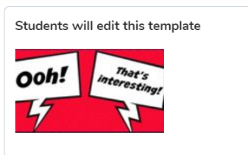 | Student Independent Practice  Our country of study is France! For international inquirers this month, we will be focusing on Geography. Research one fact about France’s geography. Draw a picture, label and/or write a sentence about your picture. Post to Seesaw
Independent Work Time  12:00-12:45 | Finish any Seesaw work  Iready reading | Finish any Seesaw work  Iready math | Finish any Seesaw work  Iready reading | Finish any Seesaw work  Iready math | Finish any Seesaw work  Iready reading
Due Dates | All Independent practice activities will be due Friday October 9^{th.} | All Independent practice activities will be due Friday October 9^{th.} | All Independent practice activities will be due Friday October 9^{th.} | All Independent practice activities will be due Friday October 9^{th.} | All Independent practice activities will be due Friday October 9^{th.}

