Week of : September 28, 2020 | Grade Level: Kindergarten
PYP Unit and Central Idea: Who We Are- Roles and responsibilities help us make connections.
Prioritized Standards Addressed This Week:
Math
MGSEK.CC.1 Count to 100 by ones and by tens.
MGSEK.CC.4 Understand the relationship between numbers and quantities; connect counting to cardinality.
MGSEK.CC.2 Count forward beginning from a given number within the known sequence (instead of having to begin at 1).
Reading/ ELA ELAGSEKRL10: ELAGSEKRF3: Know and apply grade-level phonics and word analysis skills in decoding words. ELAGSEKRL1: With prompting and support, ask and answer questions about key details in a text

Science/ Social Studies SSKE1 Describe the work that people do such as: police officer, fire fighter, soldier, mail carrier, farmer, doctor, teacher, etc. SSKCG1 Demonstrate an understanding of good citizenship. a. Explain how rules are made and why. b. Explain why rules should be followed.

Asterisk & Highlighted items will be graded
Lessons Highlighted in blue will be Synchronous Lessons (Live in Teams)
Synchronous – Live Asynchronous – Not live

Weekly sight words: Weekly word family:
Up -an (plan, ran, tan, man, can, fan, etc.)
it
and

 | MONDAY | TUESDAY | WEDNESDAY | THURSDAY | FRIDAY

Student Login/  Morning Meeting (SEL)  8:15 a.m. | Focus Lessons  Synchronous- Share Screen  Heards Ferry Live  Morning Meeting | Focus Lessons  Synchronous- Share Screen  Heards Ferry Live  Morning Meeting | Focus Lessons  Synchronous- Share Screen  Heards Ferry Live  Mrs. Marshall- Read Aloud | Focus Lessons  Synchronous- Share Screen  Heards Ferry Live  Morning Meeting | Focus Lessons  Synchronous- Share Screen  Heards Ferry Live  Morning Meeting  Announce student of the week for next week
Math  8:30 a.m. | Synchronous- Share Screen | Synchronous- Share Screen | No synchronous component today. Find the activity below and complete the assignment. | Synchronous- Share Screen  Warm-Up-Count by 10’s to 100 and count to 40 by 1’s | Synchronous- Share Screen  Warm-Up-Count by 10’s to 100 and count to 40 by 1’s
 | Student Independent Practice  In Seesaw, find the activity below. Watch the instructional video and complete the assignment.  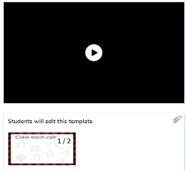 | Student Independent Practice  In Seesaw, complete the assessment below. You can help students with the technology component and reading any words only.  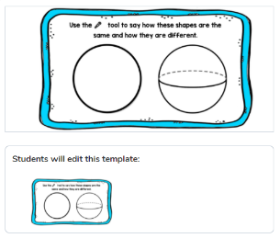 | Student Independent Practice  In Seesaw, find the activity below. Watch the instructional video and complete the assignment.  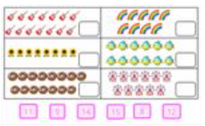  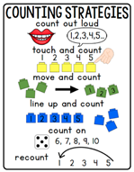 | Student Independent Practice  On Seesaw, listen to the story Ten Black Dots. Then, drag the black dots and use the drawing tool to make your own picture.  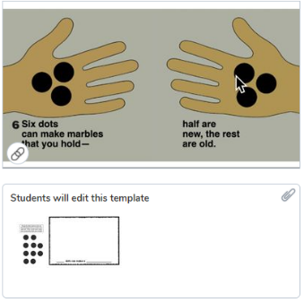 | Student Independent Practice  In Seesaw, find the activity below. Watch the instructional video and complete the assignment.  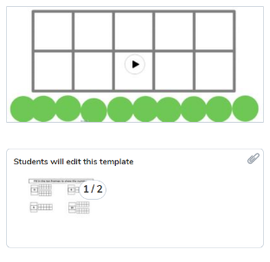
Specials  9:10am | PE with Coach K  Specials will now be conducted in Teams instead of Seesaw. When you join your specials team, find and click on the channel with our day and class name on it.  If you have any assignments to turn in, you will continue to submit them via Seesaw. | No specials day- Go Noodle, Iready reading and/or math, catch up on/begin independent practice, EPIC books, etc. | PE with Coach K  Specials will now be conducted in Teams instead of Seesaw. When you join your specials team, find and click on the channel with our day and class name on it.  If you have any assignments to turn in, you will continue to submit them via Seesaw. | Music with Mrs. LeSaicherre  Specials will now be conducted in Teams instead of Seesaw. When you join your specials team, find and click on the channel with our day and class name on it.  If you have any assignments to turn in, you will continue to submit them via Seesaw. | Art with Mrs. Strom  Specials will now be conducted in Teams instead of Seesaw. When you join your specials team, find and click on the channel with our day and class name on it.  If you have any assignments to turn in, you will continue to submit them via Seesaw.
Reading/ELA  11:15 a.m. | Synchronous- Share Screen | Synchronous- Share Screen | No synchronous component today. Find the activity below and complete the assignment. | Synchronous- Share Screen | Synchronous- Share Screen
 | Student Independent Practice  Reading  Listen to the story “The Carrot Seed” read aloud.  Listen to the instructional video on “ Pointing To and Reading Some Words and complete the activity.”  c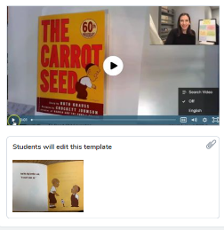  Phonics  The Letter J  On Seesaw, watch the video lesson. Then, circle the lowercase letter j that is written correctly on the lines. After, draw a picture of something that begins with the letter Jj. | Student Independent Practice  Reading  On Seesaw, watch the celebration video and complete the activity.  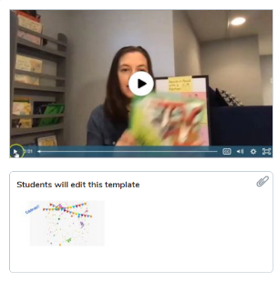  Phonics  Letter J  On Seesaw, watch the video lesson. Then, practice writing the letter J and circle the pictures that begin with J. | Student Independent Practice  Student Independent Practice  Writing  On Seesaw, watch the celebration video and complete the activity.  Phonics  Letter K  On Seesaw, watch the video lesson on letter K. Then, drag the vowels to complete the diagram. | Student Independent Practice  Writing  On Seesaw, watch the celebration video and complete the activity.  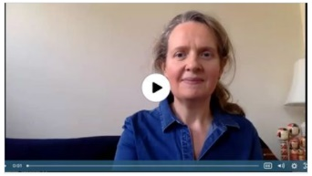  Phonics  Letter k  On Seesaw, watch the video lesson. Then, use the diagram to complete the words. Use the drawing tool to write the letter. | Student Independent Practice  Phonics  Blending board  Listen to the pre-recorded lesson and then record yourself blending 3-5 words.  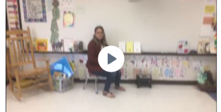
Social Studies /Science  11:45 a.m. | Focused Lesson  No synchronous component Please watch the video on Seesaw and complete the assignment | Focused Lesson  No synchronous component Please watch the video on Seesaw and complete the assignment | Focused Lesson  No synchronous component Please watch the video on Seesaw and complete the assignment | Focused Lesson  No synchronous component Please watch the video on Seesaw and complete the assignment | Focused Lesson  No synchronous component Please watch the video on Seesaw and complete the assignment
 | Student Independent Practice  Hall  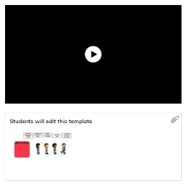 | Student Independent Practice  Bathroom  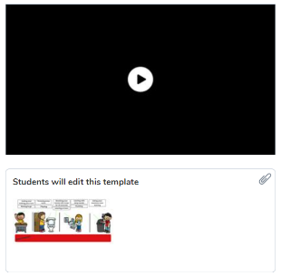 | Student Independent Practice  Cafeteria  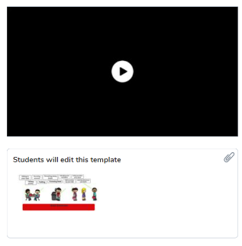 | Student Independent Practice  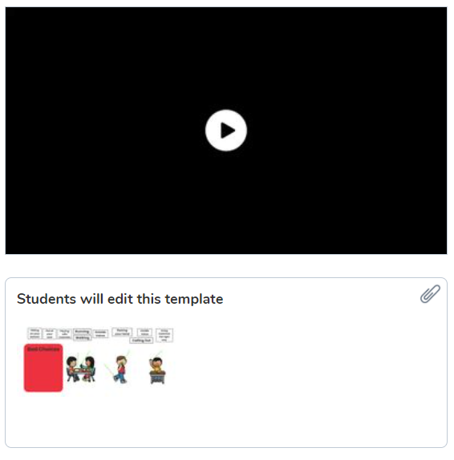 | Student Independent Practice  Expectations Review  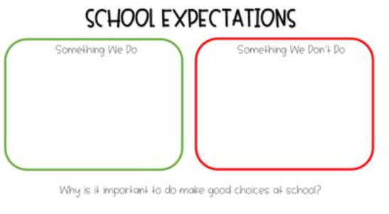
Independent Work Time  12:00-12:45 | Finish any Seesaw work  Iready math | Finish any Seesaw work  Iready reading | Finish any Seesaw work  Iready math | Finish any Seesaw work  Iready reading | Finish any Seesaw work  Iready math
Due Dates | All Independent practice activities will be due Friday October 16th. | All Independent practice activities will be due Friday October 16th. | All Independent practice activities will be due Friday October 16th. | All Independent practice activities will be due Friday October 16th. | All Independent practice activities will be due Friday October 16th.

