Week of : September 7, 2020 | Grade Level: Kindergarten
PYP Unit and Central Idea: Who We Are- Roles and responsibilities help us make connections.
Prioritized Standards Addressed This Week:
Math MGSEK.G.1 Describe objects in the environment using names of shapes, and describe the relative positions of these objects using terms such as above, below, beside, in front of, behind, and next to. MGSEK.G. 4 Analyze and compare two- and three-dimensional shapes, in different sizes and orientations, using informal language to describe their similarities, differences, parts (e.g., number of sides and vertices/“corners”) and other attributes (e.g., having sides of equal length).
Reading/ ELA ELAGSEKRL10: ELAGSEKRF3: Know and apply grade-level phonics and word analysis skills in decoding words. ELAGSEKRL1: With prompting and support, ask and answer questions about key details in a text

Science/ Social Studies SSKCG1 The student will demonstrate an understanding of good citizenship. SSKE1 Describe the work that people do such as: police officer, fire fighter, soldier, mail carrier, farmer, doctor, teacher, etc.

Asterisk & Highlighted items will be graded
Lessons Highlighted in blue will be Synchronous Lessons (Live in Teams)
Synchronous – Live Asynchronous – Not live

Weekly sight words: Weekly word family:
a -ap (nap, cap, rap, tap, map, zap, etc.)
is
my

 | MONDAY | TUESDAY | WEDNESDAY | THURSDAY | FRIDAY

Student Login/  Morning Meeting (SEL)  8:15 a.m. | No School-Labor Day | Focus Lessons  Synchronous- Share Screen  Heards Ferry Live  SEL- Who Can Help?  Video and Discuss | Focus Lessons  Synchronous- Share Screen  Heards Ferry Live  SEL- Who Can Help?  Activity | Focus Lessons  Synchronous- Share Screen  Heards Ferry Live  Morning Meeting | Focus Lessons  Synchronous- Share Screen  Heards Ferry Live  Morning Meeting  Announce student of the week for next week
Math  8:30 a.m. | No School-Labor Day | Synchronous - Whole group calendar and minilesson (Seesaw video)  Teacher will meet with small group of students who are in the classroom today.  If you are not face to face, please watch pre-recorded lesson and complete assignment listed below in “Student Independent Practice” | Synchronous - Whole group calendar and minilesson (Seesaw video)  Synchronous small group –Greedy Triangle-Teacher will meet virtually with students who are remaining virtual for phase 1 and were unable to come to school Monday due to the Labor Day holiday. For students attending this small group, please have toothpicks, qtips, straws, or something that students can manipulate to make shapes.  If you are not face to face, please watch pre-recorded lesson and complete assignment listed below in “Student Independent Practice” | Synchronous - Whole group calendar and minilesson (Seesaw video)  Teacher will meet with small group of students who are in the classroom today.  If you are not face to face, please watch pre-recorded lesson and complete assignment listed below in “Student Independent Practice” | Synchronous - Whole group calendar and minilesson (Seesaw video)  Teacher will meet with small group of students who are in the classroom today.  If you are not face to face, please watch pre-recorded lesson and complete assignment listed below in “Student Independent Practice”
 | No School-Labor Day | Student Independent Practice  In Seesaw, find the activity below. Watch the instructional video and complete the assignment.  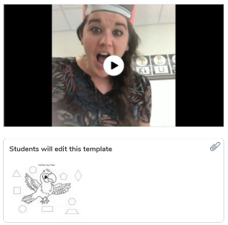 | Student Independent Practice  In Seesaw, find the activity below. Watch the instructional video and complete the assignment.  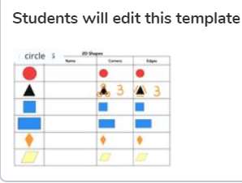 | Student Independent Practice  In Seesaw, find the activity below. Watch the instructional video and complete the assignment.  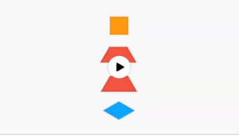 | Student Independent Practice  In Seesaw, find the formative assessment below. Watch the video and then complete the formative assessment. You can help students use the technology, but please let students demonstrate mastery of 2d shapes and position words on their own.
Specials  9:00am | No School-Labor Day | No specials day- Go Noodle, Iready reading and/or math, catch up on/begin independent practice, EPIC books, etc. | PE with Coach K  Specials will now be conducted in Teams instead of Seesaw. When you join your specials team, find and click on the channel with our day and class name on it.  If you have any assignments to turn in, you will continue to submit them via Seesaw. | Music with Mrs. LeSaicherre  Specials will now be conducted in Teams instead of Seesaw. When you join your specials team, find and click on the channel with our day and class name on it.  If you have any assignments to turn in, you will continue to submit them via Seesaw. | Art with Mrs. Strom  Specials will now be conducted in Teams instead of Seesaw. When you join your specials team, find and click on the channel with our day and class name on it.  If you have any assignments to turn in, you will continue to submit them via Seesaw.
Reading/ELA  10:00 a.m. | No School-Labor Day | Synchronous-Whole group “We Are Readers” video | Synchronous- Whole Group  “Reading- When We Are Done, We’ve Just Begun” video | Synchronous- Whole Group  “We Are Writers” video | Synchronous- Whole Group  “Writing-When We are Done We’ve Just Begun” video
 | No School-Labor Day | Student Independent Practice  Reading  In Seesaw, listen to the lesson “We Are Readers” if you weren’t able to join whole group. Everyone will complete the activity.  Phonics  On Seesaw, watch the video lesson on the letter G. Then, practice writing uppercase and lowercase letter G and circle the pictures that begin with the letter G. | Student Independent Practice  Reading  In Seesaw, listen to the lesson “Reading-When We are Done, We’ve Just Begun” if you weren’t able to join whole group. Everyone will complete the activity.  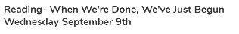  Phonics  On Seesaw, watch the video lesson on the letter G. Then, drag the pictures to sort the words that begin with the letter G and words that do not begin with letter G. | Student Independent Practice  Writing  Find the “We Are Writers!” lesson on Seesaw. Watch the lesson and look at the example if you weren’t able to join whole group. Everyone will complete the activity, using words and pictures to show everything you know about a topic of your choice. Upload a picture of your work to Seesaw.  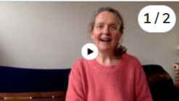  Phonics  On Seesaw, watch the video lesson. Then, practice writing uppercase and lowercase letter M and circle the pictures that begin with the letter M  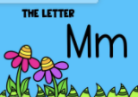 | Student Independent Practice  Writing  In Seesaw, listen to the lesson “Writing-When We are Done, We’ve Just Begun” video and look at the examples following the video. Everyone will complete the activity.  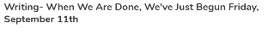  Phonics  On Seesaw, watch the video lesson. Then, use the voice recording tool to say each sound, then blend them together to read the word.  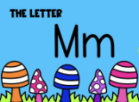
Social Studies /Science  10:45 a.m. | No School-Labor Day | Focused Lesson  Community helpers-Chef  No synchronous component Please watch the video on Seesaw and complete the assignment | Focused Lesson  Community helpers-Doctor  No synchronous component Please watch the video on Seesaw and complete the assignment | Focused Lesson  Community helpers-Vet  No synchronous component Please watch the video on Seesaw and complete the assignment | Focused Lesson  Community helpers-Police  No synchronous component Please watch the video on Seesaw and complete the assignment
 | No School-Labor Day | Student Independent Practice  On Seesaw, watch the video of a chef and complete the assignment by asking a chef a question.  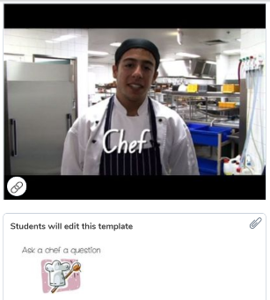 | Student Independent Practice  On Seesaw, watch the video of a doctor and complete the assignment by asking a doctor a question.  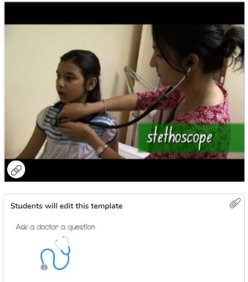 | Student Independent Practice  On Seesaw, watch the video of a vet and complete the assignment by asking a vet a question.  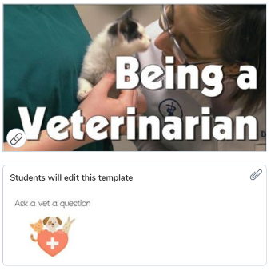 | Student Independent Practice  On Seesaw, watch the video of a police and complete the assignment by asking a police a question.  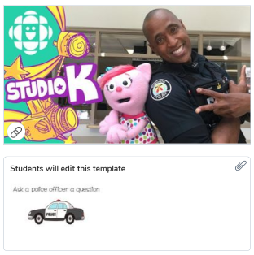
Independent Work Time  12:00-12:45 | No School-Labor Day | Finish any Seesaw work  Iready reading | Finish any Seesaw work  Iready math | Finish any Seesaw work  Iready reading | Finish any Seesaw work  Iready math
Due Dates | No School-Labor Day | All Independent practice activities will be due Friday September 25th | All Independent practice activities will be due Friday September 25th | All Independent practice activities will be due Friday September 25th | All Independent practice activities will be due Friday September 25th

