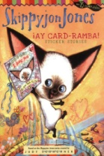
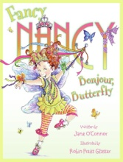
Storybook Character Day
Friday, October 30, 2020
On Friday, October 30th, we will be celebrating our favorite storybook characters! This month, each student will be preparing a presentation in class to share. Here’s what you need to do at home:
- Select a book to read together several times and then discuss the characters in it. If your child is face to face, please, have them bring this book to class by Monday, October 19th. For remote students, you can let your teacher know what book you choose by the 19th. We will be using the book from 10/19- 10/30.
- Select a character from the book and plan a costume to wear on October 30th. The costume does not have to be elaborate and can be assembled from items found around the house. (Reminder: no masks or weapons of any type!)
- In class, students will work on a presentation about the book. For remote students, you can find the template attached in this email. The template includes the body (with lines where students will write the information below), a head, 2 arms (below the head), and 2 legs (on each side of the head). Once complete, students will decorate the template to look like their character using construction paper, crayons, yarn for hair, etc. The presentation will include:
  - The title of the book
  - The name of the author
  - The name of the illustrator
  - The character the students have chosen to dress as and how they are like them and different from them.

We can’t wait to see what you come up with!

Thank you,
The K Team

